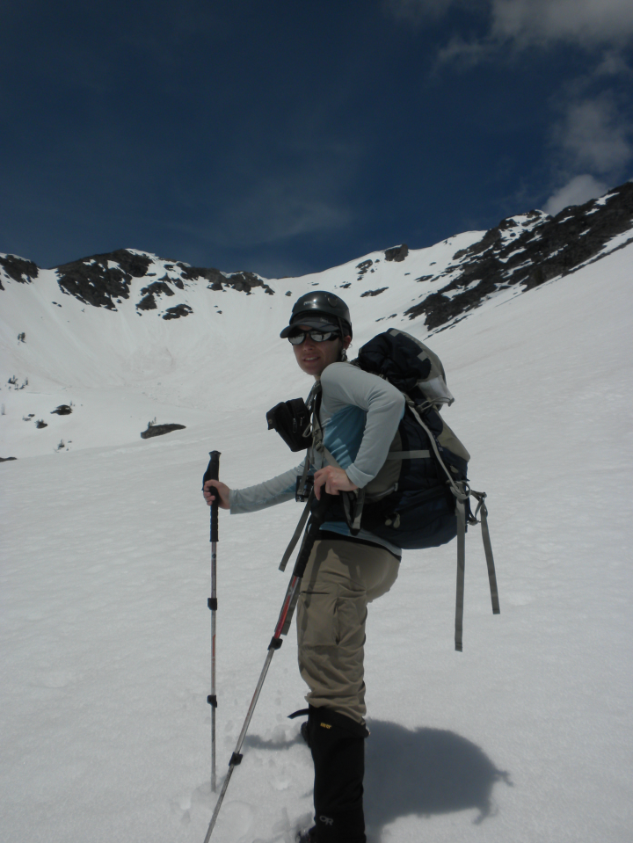
Mt. Robinson via SE Ridge (8,726ft)
June 11-12 2011
Linsey Warren (leader)
Kyle Finnegan

-Car Camp-
5.15 am – Rise and Shine
6.00 am – Hit the trail
10.30am – Camp (approximately 6,400ft)
11.00am – Begin heading up basin
3.00pm – Gain the ridge (8,000ft)
4.00pm – Summit
6.00pm – Camp

7.30am – Rise and Shine
8.00am – Head down
11.30am – Arrive back at the trailhead!

Kyle and I ran a ton of errands the night before we headed out to the North Cascades – but we finally got on the road a little after 8.30pm from Bellevue. We made it to Mazama around midnight and pitched a tent at the Robinson Creek Trailhead (9 miles west of downtown Mazama). Trying to be a little more on the realistic side of things we set the alarm for 5.00am but when it went off it took an additional fifteen minutes to get moving! We hit the trail at approximately 6.00am and headed up the Robinson Creek trail. About a mile or so along the trail we came to a ‘log crossing’ that looks to be the beginning of a really solid bridge that hasn’t been finished. There are three logs placed parallel that run across the river – and as they are fairly close together they form a good solid and wide base. Immediately after this there is a good camp spot! Really flat, shady area! But alas, we kept going! We hiked for about another mile until we crossed over Beauty Creek on a lovely bridge. Just after the bridge on your right (approximately 60-75ft) there is a decently obvious climber’s trail that begins to switchback uphill.

The hill up from Beauty Creek was covered in glacier lilies and was quite beautiful! The going was pretty straight forward but there was no obvious trail. Occasionally, we would stumble across what looked like small game trails but generally we just headed straight up running parallel to the creek coming down from the tarn. Just above snow level, at about 6,400ft we decided to ditch the heavy gear and set up camp. I found a decently level spot between some trees and we pitched the tent. I didn’t level the ground because it seemed okay – and of course that would come back to bite us later!! We grabbed some water and some food and headed uphill. It was slow going and quite hot! There was no shade in the basin and we kicked steps the whole way up! Although the ground was relatively firm it didn’t stop up for doing the occasional posthole up to our hips! We eventually made the ridge and the going was a lot easier up on the ridge. There was not as much snow and the scree was relatively stable and made for quicker going.

The east side of the ridge had some bigger cornices so we stayed well away from that! But the ridge seemed to be easier going because it was rockier and when we got off onto the snow patches they were unpredictably deep in some spots. We made it to the base of the ‘false summit’ in good time and saw the class 4 scramble route. It is a little exposed as a fall could result in a decent size tumble on either side (approximately 400ft to the east). I went ahead and traversed the little snowy col/ridge over to the scramble. The rock was fairly straight forward but there were one or two sections of rock that were covered in snow that were slightly trickier. The snow covering a couple section was very powdery and hard to make good purchase in – but that was only in one or two spots. I also walked carefully along the top of the scramble since there was snow covering the rocks there and I wanted to be careful that I didn’t puncture through a cornice or thin snow. The last bit of scramble to the summit was straightforward! I tagged the summit and down climbed the false summit and headed back down the ridge with Kyle. We were both ready to be at camp. When we got to the top of the basin we traversed over to a clean line and plunged down, glissading closer to the bottom.

After that we followed our footsteps back into camp. We melted some water and heated it up for our sleeping bags as our boots and socks were soaking wet!! Luckily for us we had brought a new Mountain House meal along, the ‘Chicken Salad’ one that only requires 10oz of cold water mixed in. So we ate that and some of our leftover snacks and called it good. We probably should have heated up the other Mountain House but crawling into a sleeping bag was just too tempting! During the night we slide a little downwards as it wasn’t quite level and condensation built up in the single wall tent because I forgot to open up the air flow zips! Opps! But fortunately we were able to get up and going and the weather held Sunday morning. The way down was relatively straight forward and we just followed our original tracks. All the streams and creeks seemed to be running quite high – but they didn’t pose any real objective hurdles. When we got back to within a mile of camp we ran into a group of day hikers who told us they’d seen a rattlesnake a little ways down the trail and that they’d marked the spot with three X’s so we’d know to look out. Very kind – but we didn’t see anything! The cars were lovely – but even better was the tasty sandwich and fresh bread from the Mazama store! Estimated 6,400ft gain and 13 miles.

Conditions/ Objective hazards – Snow conditions seemed fairly solid although there was evidence of pas sluffs and slides. Some big cornices on the ridge should be avoided. The class 4 scramble up the false summit was a little trickier with very powdery snow concealing a few harder sections – but passable.

Trail Conditions – Clear up to about 5,000ft and then there are sections of snow but they are passable and the trail is still fairly straight forward. Just after crossing the creek (which intersects Beauty Creek) we headed uphill towards the tarn. This clear terrain was fairly easy going and there were several game trails on it that made for good going too. At about 6,200ft we hit snow again and from then on up to 8,000ft (start of the ridge after the basin) and intermittently after that we were kicking steps.

Bugs - A few – saw a couple mosquitoes but nothing biting.

Water – Was available up until about 6,000ft when the river became mostly covered with snow. The tarn marked on the map is completely covered. There were a few sections of melt off flowing over rocks up high and sections where we could hear the water running under us – but not a lot of readily accessible water after 6,000ft.

Animals - Lots of deer!! We saw some larger mammal tracks but couldn’t tell what they belonged to.

Gear – Helmet, poles and snowshoes – although we did not use the snowshoes.

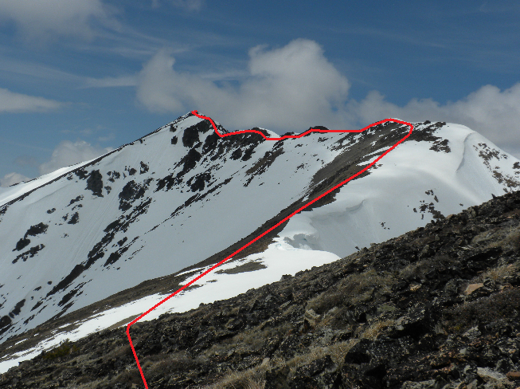
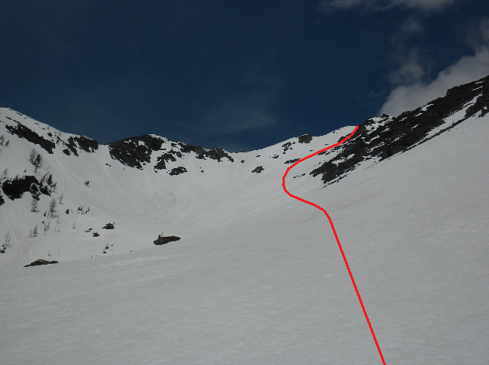
After reaching the top of the basin a look at the route along the SE ridge
Looking up the basin at approximately 6,600ft

